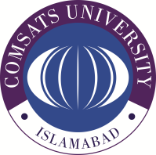**COMSATS University Islamabad, Wah Campus**

**Assignment # 03**

Department of Computer Science

|  |  |  |  |  |  |  |  |  |
| --- | --- | --- | --- | --- | --- | --- | --- | --- |
| Class/Program: | | **BS(CS)/BS(SE) – 5A/4B** | | Date: | **May 14, 2024** | | | |
| Subject: | **Database System** | | | Instructor: | | **AYESHA NAEEM** | | |
| Total Time Allowed: | | |  | Maximum Marks: | | | | **10** |
| Student Name: | |  | | Registration #: | | |  | |

**Q 01: [C2, CLO-1]**

**Question # 01: (10)**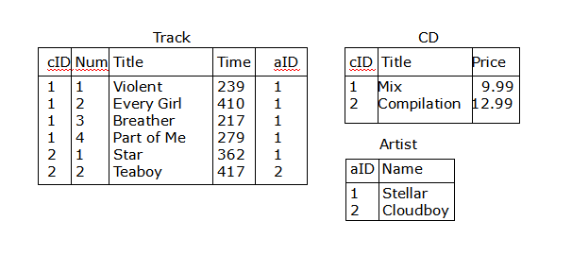

**Relational Algebra Queries:**

* Find a list of all the CD titles.
* Find a list of the titles of tracks that are more than 300 seconds long.
* Find a list of the names of those artists who have a track on the CD with the title “Compilation”.